NON-DISCLOSURE AGREEMENT TEMPLATE

This Non-Disclosure Agreement Template is a template realized on the initiative of ESIL2. This document should be considered as a starting point for negotiations and should be adapted to the specific needs of the intended deal. It is therefore a generalized document and cannot contain all elements that are of importance in specific situations. The formulation will not be relevant or optimal in certain cases. Each investor and entrepreneur remains fully responsible for the structuring of the transaction. Neither ESIL2, nor their consortium partners can be held accountable for any issues, faults, or deficiencies in the structuring of specific dossiers that would result from the usage of this Non-Disclosure Agreement Template.

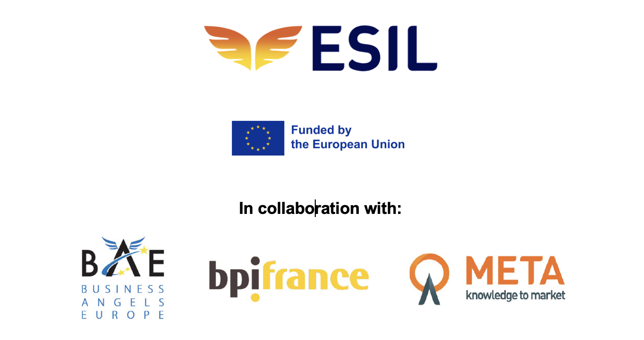

NON-DISCLOSURE AGREEMENT

PARTIES:
- [COMPANY NAME], organized under the laws of [COUNTRY], having its office at [ADDRESS] and registered with the [NAME REGISTRATION OFFICE] under number [●], duly represented for purposes of this Agreement by its director(s), [●];
- […]
- […]
OR if the angel investor is a natural person
- [NAME], born on [DATE] in [PLACE], with domicile at [ADRESS];
- […]
- […]
(the “Angel Investor”)
AND
- [COMPANY NAME], organized under the laws of [COUNTRY], having its office at [ADDRESS] and registered with the [NAME REGISTRATION OFFICE] under number [●], duly represented for purposes of this Agreement by its director(s), [●] (the “Contracting Party”);
Parties referred to above are hereinafter each individually called a “Party” and jointly the “Parties”.

PREAMBLE
- Angel Investor has the intention to invest in the Contracting Party in the manner set out below.
- Contracting Party is active in the field of [ACTIVITY].
- Parties wish to obtain and disclose Confidential Information (as defined hereinafter) to each other during discussions and contacts [on the potential acquisition of shares in the Contracting Party by the Angel Investor], [the potential contribution in cash by the Angel Investor within the Contracting Party in exchange for Angel Investor’s shares] or a similar transaction (the “Project”).
- Parties have decided, in this respect, to lay down their mutual arrangements in this agreement (the “Agreement”).

AGREEMENT:
- CONFIDENTIALITY
  - Any information, either in written form (including electronic data) or orally, including but not limited to (1) technical information, know-how, trade secrets and other intellectual property rights, processes, market opportunities, strategies, customers and potential customers, business and/or financial information, etc. related to a Party or any of its Affiliates (the “Disclosing Party”) provided to the other Party (the “Recipient”) or (2) related to the (existence of the) Project shall be considered as confidential information (the “Confidential Information”).
An “Affiliate” means a company controlled by that party, the companies controlling that party or the companies with which that party forms a consortium.
  - Parties undertake that they will:
- keep all Confidential Information strictly confidential and will not disclose the Confidential Information, either directly or indirectly, in any manner whatsoever, in whole or in part, without the prior written consent of the Disclosing Party, it being understood that they can share Confidential Information with their Affiliates provided that those Affiliates have been advised of its confidential nature and have accepted all provisions of this Agreement as binding, and provided further that, in the event of such disclosure, the Recipient shall remain liable for any prohibited disclosure and/or use of any such Confidential Information by its Affiliates;
- restrict access to any Confidential Information to their directors, officers, employees and representatives including legal, accounting, financial and other advisors on a strictly need to know basis for the purpose of evaluating the Project;
- not use any Confidential Information for any purpose other than evaluating the Project;
- not use the Confidential Information with a view to obtaining a commercial advantage over each other or Parties’ competitors;
- keep the Confidential Information secure and in such a way to prevent unauthorised access by any third party (excepting Parties’ Affiliates);
- not disclose to any third party (excepting Parties’ Affiliates) the contents of this Agreement or the fact that Parties have entered into it or that access has been given to Confidential Information or that Parties are involved in discussions or negotiations concerning the Project;
- be responsible for any breach of these undertakings.
  - The obligation to maintain the confidentiality of the Confidential Information does not apply to information that:
- at or after the time of disclosure is in the public domain other than as a result of a breach of any obligation of confidentiality;
- was lawfully within the possession of the Recipient prior to its disclosure by or on behalf of the Disclosing Party provided that the source of such information was not bound by or subject to a confidentiality agreement with any of the Disclosing Party’s Affiliates or by fiduciary or other similar duties of confidentiality;
- the Recipient is required to disclose by any court or competent jurisdiction, any public entity lawfully requesting disclosure or by any regulation, provided that the Recipient notifies the Disclosing Party in advance of such disclosure and exercises its best efforts to ensure that the Confidential Information will be treated confidentially to the maximum extent possible.
For the avoidance of doubt, the Recipient may not disclose Confidential Information made up of a combination of items of information merely because one or more of the items falls within the exceptions above, if the combination itself does not.
  - Parties acknowledge and agree that they are free whether or not to share Confidential Information with each other.
  - Each Party shall promptly notify the other if it becomes aware of any breach of confidentiality by any person to whom Confidential Information shall have been divulged hereunder, and shall give the other Party all reasonable assistance to protect its rights, or shall take appropriate defensive measures against any claim of infringement, in accordance with the instructions of the other Party.
  - Both Parties acknowledge and agree that no warranty is given, express or implied, as to the accuracy or completeness of the Confidential Information and that they will not bear any liability towards each other or any of their respective Affiliates resulting from the use of Confidential Information.
  - Notwithstanding ARTICLE 5, the provisions of this article will remain in full force and effect for the duration of the negotiations related to the Project and during five (5) years following the termination of the negotiations or the realisation of the Project.

- RETURN OF CONFIDENTIAL INFORMATION
  - Upon the Disclosing Party’s first request, the Recipient shall as soon as reasonably possible and at discretion of the Disclosing Party:
        - return to the Disclosing Party, destroy or render unusable, and discontinue the use, of any Confidential Information in the Recipient’s possession, including all copies and other materials reflecting, incorporating, or based on the Disclosing Party’s Confidential Information;
or

        - erase the Confidential Information from its computer systems and other data carriers in electronic or other form.

Upon Disclosing Party’s reasonable request, the Recipient shall certify that it has destroyed or returned all Confidential Information.
  - The Recipient may, however, retain a copy of Confidential Information to the extent required by law or any applicable governmental or regulatory authority and to the extent reasonable to permit the Recipient to keep evidence that it has performed its obligations under this NDA.
  - In the event it is technically impossible to destroy all Confidential Information, the Recipient shall inform the Disclosing Party thereof, and both Parties shall discuss how they shall resolve the situation. In such case, the obligations of confidentiality under this NDA shall remain applicable to such Confidential Information.
- EXCLUSIVITY

Exclusivity is not typically included in a standard NDA, but if desired, the following clause could be added to the agreement:
  - The Parties agrees that during the Exclusivity Period (as defined below), they shall not:
- directly or indirectly, enter into any other negotiation or agreement with any third party which relates to whole or part of the Project or a project similar to the Project;
- directly or indirectly, realize whole or part of the Project or any similar project, no matter how, on their own or through any Affiliate or jointly with any third party.
  - The Parties warrant and guarantee that its representatives, employees and advisors comply with the obligations set forth in article 2.1.
  - Notwithstanding ARTICLE 5, the provisions of this article will remain in full force and effect for the duration of the negotiations related to the Project and during three (3) months following the termination of the negotiations (the “Exclusivity Period”).]
- NON-SOLICITATION
  - Without prior written consent, neither Party nor any of their respective Affiliates nor anyone acting on their behalf will, directly nor indirectly, during the discussions and negotiations relating to the Project and for a period of three (3) years after the termination of negotiations relating to the Project, either directly or indirectly, approach any executive or any employee of the other Party with whom it has had contact or who (or whose performance) became known to it in connection with the matters subject of this Agreement, with regard to an employment or the provision of management services, provided that a Party may hire a person who has not been employed by or has not provided any management services to the other Party during twelve (12) consecutive months. Further neither Party nor any of their respective Affiliates nor anyone acting on their behalf will, for a period of three (3) years from the date of this Agreement, directly or indirectly divert or attempt to divert any business, supplier, customer, licensor, licensee, agent, representative or (sub-)contractor of the other Party through the use of any knowledge or information obtained from the Confidential Information, other than in the normal and proper course of ordinary business activities.
  - The Parties acknowledge that the restrictions as mentioned in article 3.1 are reasonable and necessary for the protection of the legitimate interests of each other. In the event that the non-solicitation clause in article 3.1 shall ever be held to exceed the legal limitations, this article 3.1 shall not be null and void but the Parties shall deemed to have agreed to such provision as conform with the maximum permitted by law.
- REMEDIES - PENALTY
  - Without prejudice to any other rights or remedies a Party may have, Parties acknowledge and agree that solely damages would not be an adequate remedy for any breach of this Agreement. A Party shall be entitled to any remedies, including an injunction.
  - In case of an infringement of this Agreement, the Recipient shall pay a lump sum penalty of EUR [50,000] for each infringement, to be increased by EUR [5,000] per day that such infringement continues after reception of a written notice, without prejudice to the right of the Disclosing Party to claim additional damages, if it can establish that it has incurred losses exceeding the above amounts.
- DURATION - TERMINATION
  - Each Party can terminate the negotiations related to the Project, at any stage, by means of a written notice. Neither Party shall be liable to the other Party for any loss whatsoever arising as a consequence of the termination of the negotiations.
- INTELLECTUAL PROPERTY
  - This Agreement shall not be construed as granting expressly or implicitly any rights, including, without limitation, license rights, patents, copyrights or any other form of intellectual property rights belonging to the Disclosing Party or any of its Affiliates in respect of the Confidential Information, the ownership of which shall remain vested in the Disclosing Party at all times.
- MISCELLANEOUS
  - No failure or delay by a Party or its representatives in exercising any right under this Agreement shall operate as a waiver thereof, nor shall any single or partial exercise thereof preclude any other or further exercise thereof or the exercise of any right, power or privilege hereunder.
  - This Agreement constitutes the entire agreement between Parties in respect of the matters to which this Agreement relates and supersedes all previous communications between them, whether oral or written. This Agreement may only be amended in writing.
  - This Agreement is personal to the Parties (“intuitu personae”). It may not be transferred to third parties in any manner without prior written consent of the other Party.
  - In the event that one or more provisions of this Agreement shall be, or shall be deemed to be, invalid or unenforceable, the validity and enforceability of the other provisions of this Agreement shall not be affected thereby. In such case, Parties agree to recognize and give effect to such valid and enforceable provision or provisions which correspond as closely as possible with their mutual intent. The same applies to any gaps or omissions in this Agreement.
- GOVERNING LAW – JURISDICTION
  - This Agreement shall be governed by and construed in accordance with the laws of [COUNTRY].
  - Any dispute arising out of or in connection with it shall be submitted to the exclusive jurisdiction of the courts of [CITY], [COUNTRY].

[SIGNATURE PAGE FOLLOWS]

Executed on [DATE], in as many originals as there are parties. Parties agree that (i) electronic signatures which qualify as an advanced or a qualified e-signature under the eIDAS Regulation (Regulation (EU) N°910/2014) or (ii) scan copies of duly signed counterpart signature pages to this Agreement transmitted by email in .pdf format, will have the same probative value as a wet ink original paper document bearing a manually signed signature.

For and on behalf of ANGEL INVESTOR
_________________________  Name: [●]  Capacity: [●] | _________________________  Name: [●]  Capacity: [●]

For and on behalf of the CONTRACTING PARTY
_________________________  Name: [●]  Capacity: [●] | _________________________  Name: [●]  Capacity: [●]

This document is provisional and is currently pending input from a local legal expert. It provides only a general overview and should not be considered complete or legally binding. Under no circumstances can it considered to be binding legal advice.
Neither ESIL2 nor any of the consortium partners, contributors or affiliates can be held responsible for any errors, omissions, or deficiencies in these templates, nor for any issues or disputes arising from their use. The responsibility for the final structuring, negotiation, and execution of any transaction lies solely with the users.
Please contact a qualified attorney for specific advice regarding the national legislation.

Always verify whether the signatory is authorized to sign the NDA.
If there are multiple Angel Investors, this list should be completed with the details of all Angel Investors.
Always verify whether the signatory is authorized to sign the NDA.
If relevant, include more information, e.g. process of Parties finding each other, or any other information that might be relevant in relation to the goals of the Parties.
This provision should be tailored to the specifics of the proposed transaction, as it will vary depending on whether the transaction involves a (convertible) loan, an equity transaction, or another type of investment.
It is very important to clearly define what constitutes Confidential Information and how it should be treated. You can customize the list based on the specific needs and preferences. However, Confidential Information should be related to the Project and any information disclosed in that context.
An Exclusivity clause is not typically included in a standard NDA, but can be considered in cases where exclusivity is desired from the beginning of the investment. Please take into account that the exclusivity clause may only apply to a restricted period (3 weeks – 3 months) and must not unreasonably prevent a company from seeking other investors. A consideration when using an exclusivity clause at this stage of the investment is that it could be used by Angel investors who have no intention of investing. Caution is therefore advised when using exclusivity
A non-solicitation clause is not typically included in a standard NDA, but it can be highly relevant during due diligence, especially when sharing confidential employee information. This clause helps prevent the solicitation or hiring of employees from the disclosing party, safeguarding workforce stability and protecting sensitive employee data.
Including a remedies or penalty clause, such as a fixed compensation, in an NDA can be beneficial because it provides a straightforward consequence for breaches where proving damages is challenging. The fixed compensation serves as a predefined remedy, offering assurance to the Disclosing Party and deterring potential breaches by the Receiving Party. This approach simplifies dispute resolution by outlining clear consequences for violating confidentiality obligations. However, it's important to ensure that the fixed compensation is reasonable and proportional to the potential harm caused by a breach. Ultimately, such clauses can streamline enforcement but require careful consideration to balance effectiveness with fairness. In any case, if Article 4.2 is not accepted by the Contracting Party, it seems appropriate to negotiate that Article 4.1 be retained.
We propose designating the law of the Contracting Party's registered office as the governing law.
We propose to designate the courts of the Contracting Party's registered office as the competent jurisdiction.
If there are multiple Angel Investors, this signature page should be modified so that all Angel Investors can sign this agreement.

